Plenary meeting of the

Quality Knowledge Exchange Network

Athens, Greece

18th – 20th May 2016

Draft Agenda

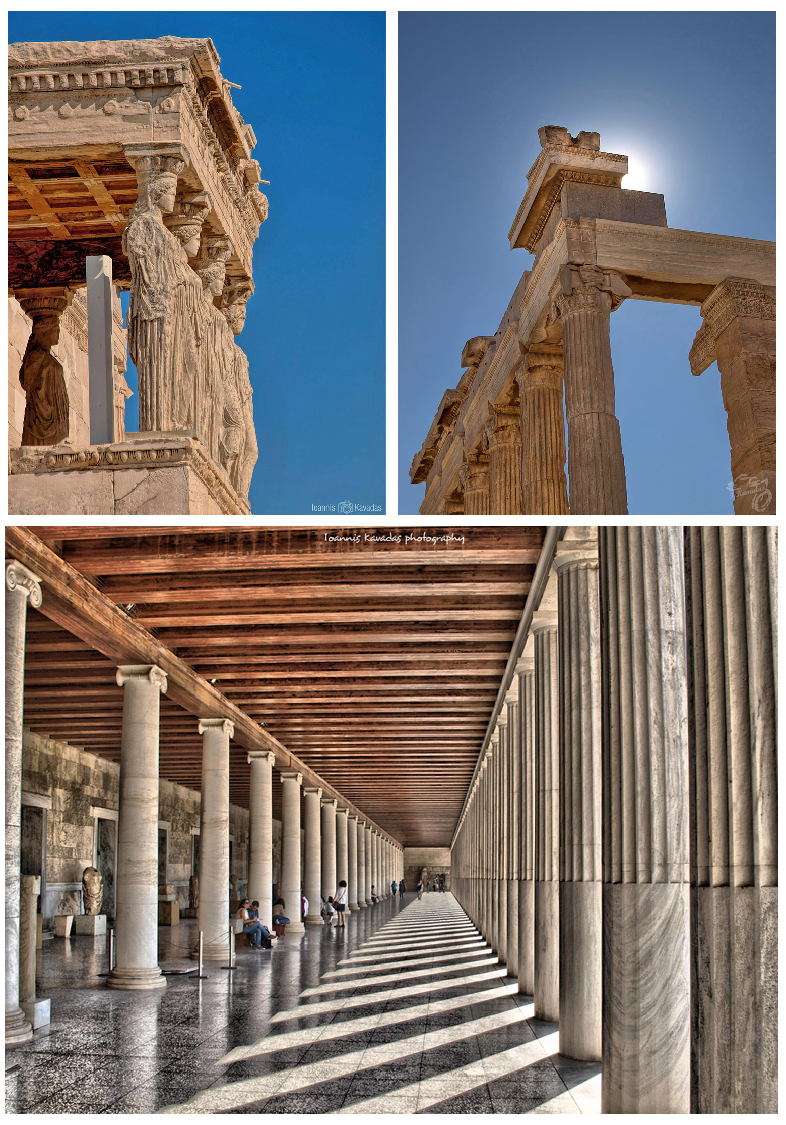
 |  | Item | Lead
18th May |  | Day 1
09:00 – 09:15 |  | Opening of the meeting | NCMA Greece
09:15 – 10:00 |  | Introduction, Changes in membership, Main objectives and outstanding actions. | Jonathan
10:00 – 10:30 |  | News from Head Office | Carol
10:30 – 10:45 |  | Future Meetings | Jonathan
10:45 – 11:15 |  | Coffee break
11:15 – 11:30 |  | Terminology | Ourania
11:30 – 12:00 |  | Quality control process for the updating of our roads and buildings (scale 1:10k) | Karin
12:00 – 12:30 |  | Building monitoring in Hungary | Tamás
12:30 – 13:00 |  | Implementation of ISO 19157 in HMLR | Gareth
13:00 - 14:00 |  | Lunch
14:00 – 17:00 |  | Group Work – Coffee to be taken at a convenient point ISO Handbook and EuroSDR paper. | All
17:00 |  | End of 1st day
19:00 |  | Walk in the old city center and dinner at own expense
19th May |  | Day 2
09:00 – 09:30 |  | QC of Orthoimages and DEM’s | D. Chrysafinos / NCMA
09:30 – 10:00 |  | A summary review of the Hellenic Cadastral Project | D. Rokos / NCMA
10:00 – 10:30 |  | NCMA’s GIS Services | G. Mourafetis / NCMA
10:30 – 11:00 |  | Future Webinars | Jonathan
11:00 – 11:30 |  | Coffee break
11:30 - 12:00 |  | Work on social responsibility | Thierry
12:00 – 13:00 |  | 1Integrate for ArcGIS | 1Spatial
13:00 – 14:00 |  | Lunch and group photo
14:00 – 16:30 |  | Whole dataset validation and use of FME.  Coffee to be taken at a convenient point | 1Spatial
16:30 – 17:00 |  | ELF | Carol
18:00 |  | Visit to the Acropolis Museum
20:30 |  | Official Dinner
20th May |  | Day 3
09:00 – 10:00 |  | National Reports | Gunhild & All
10:00 – 10:30 |  | Selection of Presentations | All
10:30 - 11:00 |  | New GIS environment for the production of the 5K Topo DB based on Geomedia | Dolors
11:00 – 11:30 |  | Coffee break
11:30 – 11:45 |  | Quality Practitioner Certificate | Jonathan & Gunhild
11:45 – 12:00 |  | ISO Standards Update | Gunhild
12:00 – 12:15 |  | ISO 19131 Handbook | Gunhild
12:15 – 12:30 |  | Wrap up | Jonathan
 |  | End of meeting

