Plenary meeting of the

Quality Knowledge Exchange Network

Dublin, Ireland

23rd – 25th May 2018

Agenda

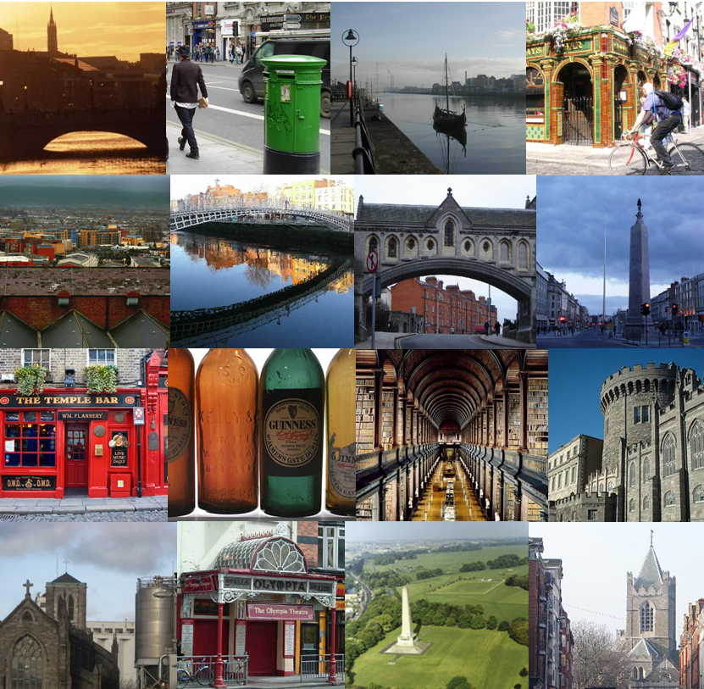
 |  | Item | Lead
23rd May |  | Day 1
09:00 |  | Opening of the meeting and welcome by Colin Bray (CEO Ordnance Survey Ireland)
09:15 |  | Introduction, health and safety, changes in membership, main objectives and outstanding actions. | Jonathan
09:45 |  | News from Head Office | Carol
10:30 - 11:00 |  | Coffee break
11:00 |  | Geohive | Lorraine / Eamonn
11:30 |  | Data Quality Rules – Prime2 | Peter
12:00 |  | Named Group Editor | Peter
12:30 - 13:30 |  | Lunch
13:30 |  | National Presentations | Gunhild / All
14:30 |  | Selection of presentations for next plenary | All
15:00 |  | New EuroGeographics Website and brand | Carol
15:30 – 16:00 |  | Coffee break
16:00 |  | ISO Standards Update | Gunhild
16:30 |  | Automated Data Processes for Aerial Imagery | Stefan (Swiss Topo)
17:00 |  | Close
20:00 |  | The Church Restaurant
24th May |  | Day 2
9:00 |  | Core reference data | Carol
9:30 |  | Group Work – Defining the value of Authoritative Data (coffee to be taken at a convenient point) | Jonathan
12:30 – 13:45 |  | Lunch and group photo
13:45 |  | Implementing DQ Standards – Motivators/Barriers | Serena Coetzee
14:45 |  | SDQ2018 – feedback and future plans | Carol
15:15 |  | Coffee break
15:45 |  | Data Quality and Linked Data | Eamonn Clinton (OSi)
16:15 |  | Close & Transfer to Trinity College Library
20:00 |  | Quay 16 Restaurant on the MV Cill Áirne
25th May |  | Day 3
09:00 |  | Eliciting User and Producer Views on Geospatial Data Quality | Hasti Ziaimatin
10:00 |  | ISO Handbook update | Gunhild / Jonathan
10:30 |  | Coffee break
11:00 |  | QKEN administration  - Future Meetings  - Quality practitioner certificate  - Future webinars  - Feedback from EXGA | Jonathan
11:30 |  | ROI | All
11:50 |  | Wrap up | Jonathan
12:15 |  | End of meeting

