Plenary meeting of the

Quality Knowledge Exchange Network

Ljubljana, Slovenia

5th – 7th April 2017

Agenda

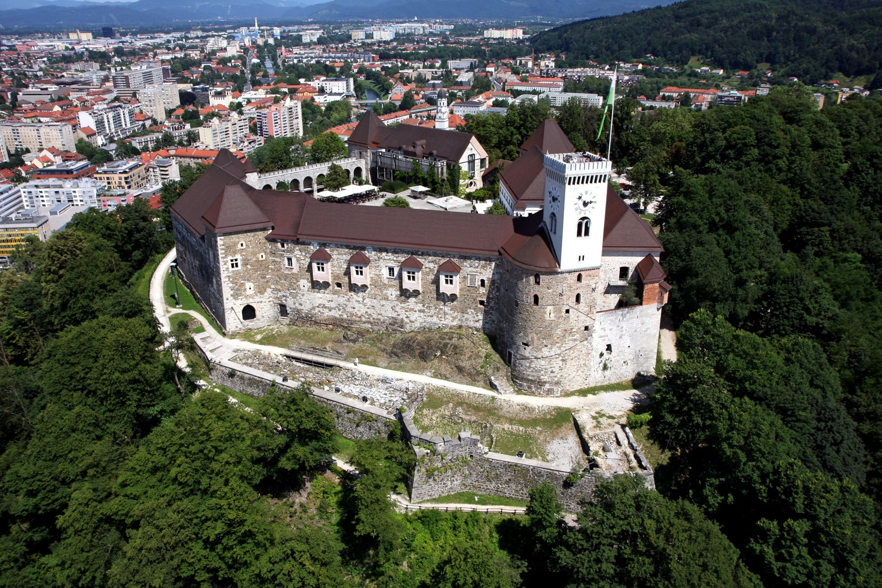
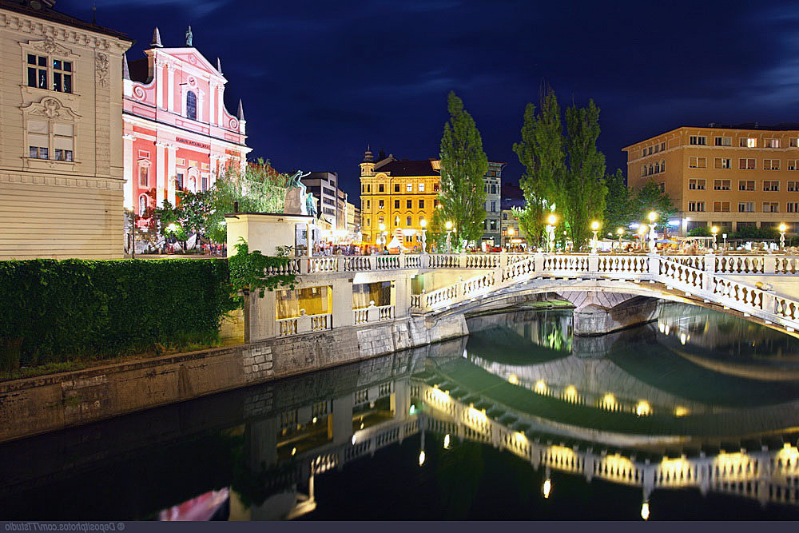
 |  | Item | Lead
5th April |  | Day 1
09:00 |  | Opening of the meeting, health and safety
09:15 |  | Introduction, Changes in membership, Main objectives and outstanding actions. | Jonathan
09:45 |  | News from Head Office | Carol
10:30 |  | Coffee break
11:00 |  | Methodology to ensure consistency of data between cadastral map and orthophotos | Ilze
11:30 |  | Multi Resolution Data Store (MRDS) | Peter
12:00 |  | ISO Standards Update | Gunhild
12:15 |  | Future Meetings | Jonathan
12:30 - 13:30 |  | Lunch
13:30 |  | National Reports | All
14:30 |  | Selection of presentations | All
15:00 |  | Discussion and selection of future webinars | All
15:30 – 16:00 |  | Coffee break
16:00 |  | Open Data | Thierry
16:30 |  | Joint EuroGeographics / EuroSDR workshop | Jonathan
16:45 |  | Quality Practitioners Certificate | Jonathan
17:00 |  | Close
19:00 |  | Evening Meal
6th April |  | Day 2
09:00 |  | Host presentations  - SMA presentation  - Quality issues and SMA  - Improvement of data in the new E-space project | Tomaž Petek  Irena Ažman  Franc Ravnihar
11:00 |  | Coffee break
11:30 |  | ISO Standards Questionnaire Results | Gunhild
12:15 |  | Terminology Update | Jonathan
12:30 – 13:45 |  | Lunch and group photo
13:45 |  | Group work. Creating a Data Quality Model  Coffee to be taken at a convenient point.
16:30 |  | Close
17:00 |  | Boat Cruise on the River Ljubljanica
19:00 |  | Official Dinner
7th April |  | Day 3
09:00 |  | Document digitising project - Local Land Charge Evolution (including discussion) | Rod
10:00 |  | Document system for Data Specifications | Gunhild
10:30 |  | Coffee break
11:00 |  | Report on crowdsourcing workshop | Carol
11:20 |  | ISO Guidelines Update | Gunhild
11:40 |  | Quality Conference in Malta | Jonathan
11:50 |  | Wrap up | Jonathan
12:00 |  | End of meeting

